Utilizing the ThorCon Molten Salt Reactor base design for grid integration

By: Pedro Vicente Valdez, Joseph Lee, and Adria Peterkin

**Technology Overview**

ThorCon’s molten salt reactor design concept involves the main components being sealed in a “can”. Inside every “can” there are 550 MWt reactor, scale of the MSRE reactor, along with the primary loop heat exchanger (PHX) and a primary loop pump (PLP). The pump takes the liquid fuel salt from the reactor and pushes it to the PHX. The fuel-salt then travels down the PHX where it transfers heat to a secondary salt. After this, the fuel salt again flows through the reactor core which is mostly filled with graphite slabs, the moderator, and a portion of the uranium fissions as it rises through the reactor core. In the process, a portion of the thorium is turned into fissile uranium, a form of breeding. The secondary salt loop, outlined in green, carries a mixture of sodium fluoride and beryllium fluoride. Hot secondary salt is pumped out of the top of the PHX to a secondary heat exchanger where it transfers the heat to a mixture of sodium nitrate and potassium nitrate commonly called solar salt, outlined in purple. This solar salt transfers its heat to a steam loop creating supercritical steam and reheats the steam to increase the plant’s efficiency (Figure 1).

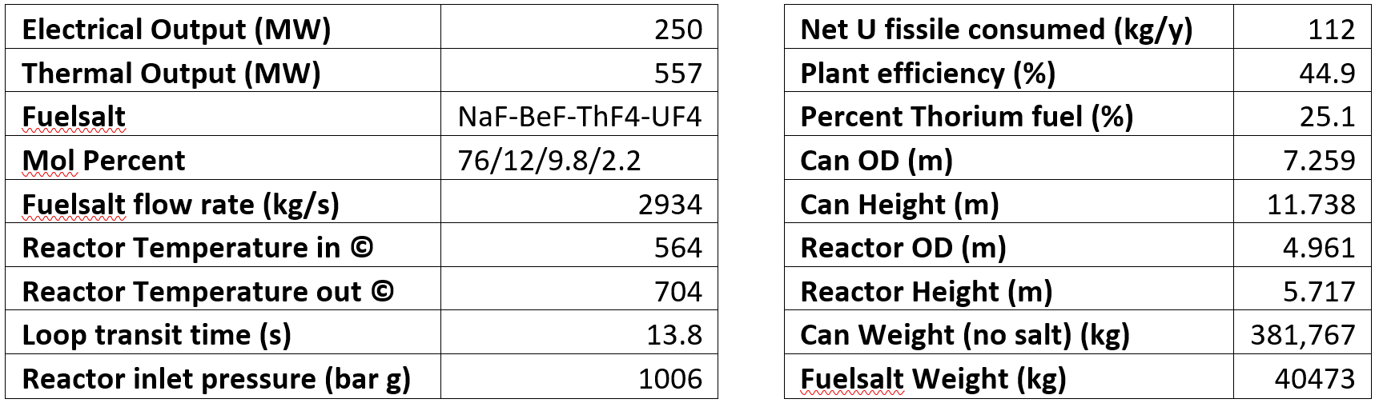

In dealing with the thermal expansion the reactor and the PHX hang from the “can” lid by cables allowing the can to expand independently from the PLP. The cables also allow the reactor and the PHX to be pushed apart as the primary loop heats up. The cables do not only allow the PHX to move laterally but also to tilt and rotate (Hammock Suspension System). Directly below the Can is the fuelsalt drain tank (FDT). In the bottom of the can there is a fuse valve (freeze plug) which is merely a low point in a drain line. If the reactor heats up for any reason, the plug will thaw, and the fuel salt will drain to the FDT. The drain is totally passive. Because of the reactor size we expect moderately high-power density of about 16 MW per cubic meter of active core. This involves changing the core graphite every four years and therefore the cans are arranged in pairs to make up a power module. Before shutting down, the first can will transfer the fuel salt to the new can (which is in standby or cool down mode) while the old one undergoes maintenance meaning there is no stopping or interruption of power.

If we were to take a 1GWe ThorCon, which would be made up of two 500 MWe silo halls with all the respective components, the plant could fit easily on a 25-acre site (Figure 2). Since the plant is underground there is plenty of room on the site surface to place other type of renewable technologies like solar or wind depending on the geographical conditions.

Some of the other key design specifications that make ThorCon an impressive choice for a base reactor include the following:

*The Membrane Wall and Passive Decay Heat Cooling*

Each Silo in the system is fitted with a membrane tube wall. The wall has been designed using vertical steel tubes connected with welded steel plates. These tubes are filled with water and connected by circular header, which is connected to the heat exchanger, and the bottom is connected to the outlet heat exchanger. Having the wall built in has allowed the can to be cooled with thermal radiation, while the heat converts a portion of the water to steam, it moderates the can’s interior temperature, cools the FDT, and captures tritium from permeating through the can or drain tank.

*Passive Shutdown*

The membrane wall and the FDT are what permits the reactor to have passive shutdown. If the temperature in the can has an aberrant increase in temperature, it will concurrently cause the membrane wall to have an increased temperature. This causes the FDT to become less viscous and further induces the fission power output to zero.

*Silo Cavity*

One of the major components of the Silo Capacity is the radtank. The radtank operates as a radiation barrier. It is a 3m deep tank filled with borated water above each can. The borated water is projected to serve as a more effective neutron shield than borated concrete because it doesn’t crack. The four barriers that protect the fuel salt from the environment include the primary loop piping, the can/FDT, the silo cavity, and the silo hall.

*Steam Generation*

The steam generator utilizes a four-loop design process. The heat generated from the system is transferred from the fuel salt in the primary loop of the can to the secondary salt, then to the tertiary salt, and finally to the steam cycle. The system has the ability to use a range of salts; the primary salts used are eutectic $NaF⋅BeF_{2}⋅ThF_{4}⋅UF_{4}$, and $NaF⋅{BeF}_{2}$, which can also be referred to as nabe. The nabe is spiked with $82\%/18\%$ mixed with thorium and enriched uranium. However, the tertiary loop of the system uses $55\%/45\% NaNO_{3}⋅{KNO}_{3}^{}$. All of the tritium that escapes the removal system in the can will end up in the tertiary loop, and will be oxidized to tritiated water. All four loops including the heat exchanger and pumps are made of stainless steel. The chosen material assist with corrosive properties of the material.

*The Sentry Turbine*

The ThorCon reactor has the ability to function as a standalone reactor. It has a 30 MWe oil or gas fired auxiliary boiler and a 15 MWe sentry turbogenerator. If a blackout were to occur, the sentry turbine will operate for several hours on decay heat, giving the reactor time to bring the auxiliary boiler online.

**Economics**

The purpose of this project is to identify methods by which nuclear power plants can respond to changing demands and supply of electricity. This will prevent power plants from selling electricity at a loss and thus save the plant money throughout the year. However, given the untried nature of the reactor and load following process we plan to use, a financial case must be made to identify if our project truly does save plants money. Clearly, it does not make sense to pursue advanced reactors or hybrid systems if it costs the more than using conventional reactors and practices.

There are many factors that attribute to the cost of a nuclear power plant. The main ones are construction costs, regulation induced costs, and continued operation costs. Construction costs can be broken into two sections: the nuclear and conventional island. The nuclear island consists of things related to the primary loop like pumps and core while the latter consists of things like the turbines, control room, and reactor vessel. Regulatory costs increase the other two due to the stringent rules placed on nuclear reactors. Furthermore, appropriate licensing is necessary for a nuclear reactor which is far from cheap. Continued operation includes things like maintenance, fuel, community services provided by the plant, and staffing. This report will primarily focus on the costs of construction and licensing.

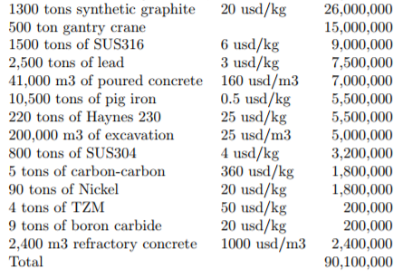

ThorCon estimates the total cost of all the raw materials for the nuclear island in the figure above. There is little argument with the estimated raw material costs given that these numbers are likely to have come from existing market data. Furthermore, ThorCon estimates that the total cost of building the nuclear island to be only 200M which is much lower than that of conventional reactors. This number was identified by assuming shipyard like productivity and efficient regulation.

Cost and construction time are one of the same and as such, a reduction of cost can be made by reducing the construction times. ThorCon’s MSR’s strive to achieve this by using simple modular components for their cans which will be built on an assembly line. Simplified design of modular components allows for mass production in a near site factory and removes the need for specialized time intensive parts. Given this information, a ThorCon plant is said to be able to be built in less than two years though a four year construction time is assumed for their cost calculations. This conservative estimate is still lower than the average construction time of the reactors built in the last 20 years was around 5-6 years.

While efficient management and simplified designs can reduce construction times, licensing regulations still significantly affect the time it takes to get the reactor online. ThorCon’s time estimates assume efficient regulations and an airplane manufacturing like regulatory system but they have little control over this aspect. While it is difficult to gauge the regulatory efficiency, steps can be taken to reduce time spent in regulatory purgatory. Pre-licensed designs can be used to streamline this process. We also plan to reduce this time by placing our plant at old decomissioned plants (eg Humboldt Bay and DCCP (by 2025)) to reduce the time of getting a site permit.

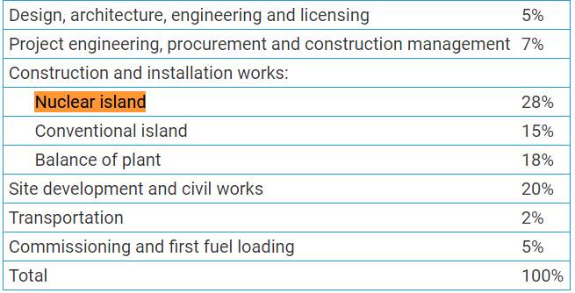

The above figure is the 2016 edition of the World Nuclear Association's *World Nuclear Supply Chain*. This break down analyzes the average costs of different aspects of the nuclear power plant and if we assume that these numbers can also be extended from BWR/PWR’s to MSR’s, then we expect that the cost of the entire plant using ThorCon’s nuclear island cost estimate will be around 800M while ThorCon is aiming for 600M. With estimates of construction costs for conventional reactors hovering around 10-20B, has the potential to increase the viability of nuclear power and its integration to a grid with deep renewable penetration.

We also take a brief look at the costs of introducing a secondary system. A 2015 INL paper with a 600 MWt reactor examines the costs of adding a desalination unit and gas generating unit and estimates the cost of each to be around $33,000 per kg/s of water treated and $13,000 per kg/hr of oil generated. Given that desalination rates can fluctuate from around 20000 m^3/hr to 60000 m^3/hr, the cost of this unit can be expected to be around $180-$540M. On the other hand estimates for the gasoline production plant (GPP) are $351M. Assuming the secondary process is producing on average 45.3 kg/s of gasoline throughout the year at a 90% CF, the expected revenues are around 1.2B.

**Appendix**

**http://thorconpower.com/docs/exec_summary2.pdfN**

(preapproved) <https://www.nrc.gov/reading-rm/doc-collections/nuregs/brochures/br0298/br0298r2.pdf>

<http://www.world-nuclear.org/information-library/economic-aspects/economics-of-nuclear-power.aspx>

INL Nuclear Hybrid Energy Systems - Regional Studies: West Texas & Northeastern Arizona

